Seventh Sunday of Easter - May 24, 2020
Permission to podcast/stream the music in this service obtained from One License: #A-733911
All music printed with permission: CCLI #1528365 and RESOUNDworship.org

GREETING and ANNOUNCEMENTS
PRELUDE God of our Fathers (Marshall)

PRAYER OF INVOCATION & CONFESSION
Pastor: Let us pray together in one voice:
All: God of our fathers and mothers, you are the Almighty, All-Merciful God and so we come into this time of worship, confessing our failures. We have allowed our prejudices to blind us to the commonality of all people. We have embraced our fears and insecurities, rather than surrendering them to your ideals of love and harmony, for through Jesus Christ, you have taught us to love one another, to love our neighbors as ourselves, and even to love our enemies. Ours is a world of such opposing information that it is often difficult to find the truth. Remind us again, that Jesus is the Way, the Truth, and the Life. In times of conflict, uncertainty, and fear let the peace of Christ rule in our hearts, so that we may not be overcome with evil but overcome with good. Forgive us when we allow self-pride to stand in the way of human concern. Comfort and challenge us in this hour of worship that we might grow to see each and every person as one created in your image and in light of the love and grace you have shown us in Christ. Work through us, that a future where peace reigns, justice is done with mercy, and all are reconciled is established among all people on earth. We ask these things in the name of Jesus Christ, our one and only Lord and Master of our hearts. Amen.

ASSURANCE OF FORGIVENESS
Pastor: Beloved people of God, hear the Good News: Nothing can separate us from God’s redeeming love.
All: Praise be to God! May I receive God’s amazing grace and may the Prince of Peace work in my heart and mind, that peace on earth, may begin with me.

SPECIAL MUSIC Let There Be Peace on Earth Dr. Troy Winemiller, Solo

EPISTLE READING 1 Peter 4:12-14, 5:6-11
Dear friends, do not be surprised at the fiery ordeal that has come on you to test you, as though something strange were happening to you. But rejoice in as much as you participate in the sufferings of Christ, so that you may be overjoyed when his glory is revealed. If you are insulted because of the name of Christ, you are blessed, for the Spirit of glory and of God rests on you.

Humble yourselves, therefore, under God’s mighty hand, that he may lift you up in due time. Cast all your anxiety on him because he cares for you.
Be alert and of sober mind. Your enemy the devil prowls around like a roaring lion looking for someone to devour. Resist him, standing firm in the faith, because you know that the family of believers throughout the world is undergoing the same kind of sufferings.
And the God of all grace, who called you to his eternal glory in Christ, after you have suffered a little while, will himself restore you and make you strong, firm and steadfast. To him be the power for ever and ever. Amen.
Liturgist: This is the Holy Word of God, let all the people say, “Thanks be to God.”
All: Thanks be to God!
HYMN Together We Serve
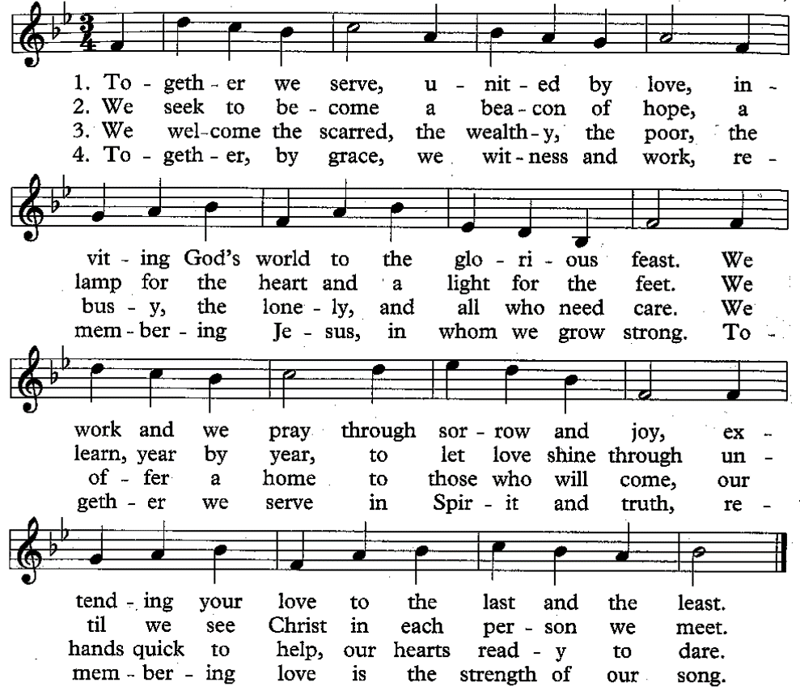

GOSPEL READING John 17:1-11 (NIV)
After Jesus said this, he looked toward heaven and prayed:
“Father, the hour has come. Glorify your Son, that your Son may glorify you. ² For you granted him authority over all people that he might give eternal life to all those you have given him. ³ Now this is eternal life: that they know you, the only true God, and Jesus Christ, whom you have sent. ⁴ I have brought you glory on earth by finishing the work you gave me to do. ⁵ And now, Father, glorify me in your presence with the glory I had with you before the world began.
⁶ “I have revealed you to those whom you gave me out of the world. They were yours; you gave them to me and they have obeyed your word. ⁷ Now they know that everything you have given me comes from you. ⁸ For I gave them the words you gave me, and they accepted them. They knew with certainty that I came from you, and they believed that you sent me. ⁹ I pray for them. I am not praying for the world, but for those you have given me, for they are yours. ¹⁰ All I have is yours, and all you have is mine. And glory has come to me through them. ¹¹ I will remain in the world no longer, but they are still in the world, and I am coming to you. Holy Father, protect them by the power of your name, the name you gave me, so that they may be one as we are one.
Liturgist: This is the Good News of Jesus Christ. Let all the people say, “Praise be to Christ.”
All: Praise be to Christ.

SERMON & PASTORAL PRAYER Rev. Laura C. Bair

OFFERING INVITATION

OFFERTORY PRAYER
All: Loving God, we present to you our tithes and gifts. Hold us to our promises, that we might share your blessings, work for justice and be peacemakers in this world for which your Son, Jesus the Christ, loved and died to save. We pray as He taught us saying: Our Father, who art in heaven, hallowed by Thy name. Thy kingdom come; Thy will be done on earth as it is in heaven. Give us this day our daily bread and forgive us our debts as we forgive our debtors; and lead us not into temptation but deliver us from evil for Thine is the kingdom and the power and the glory forever. Amen.

HYMN God Bless America
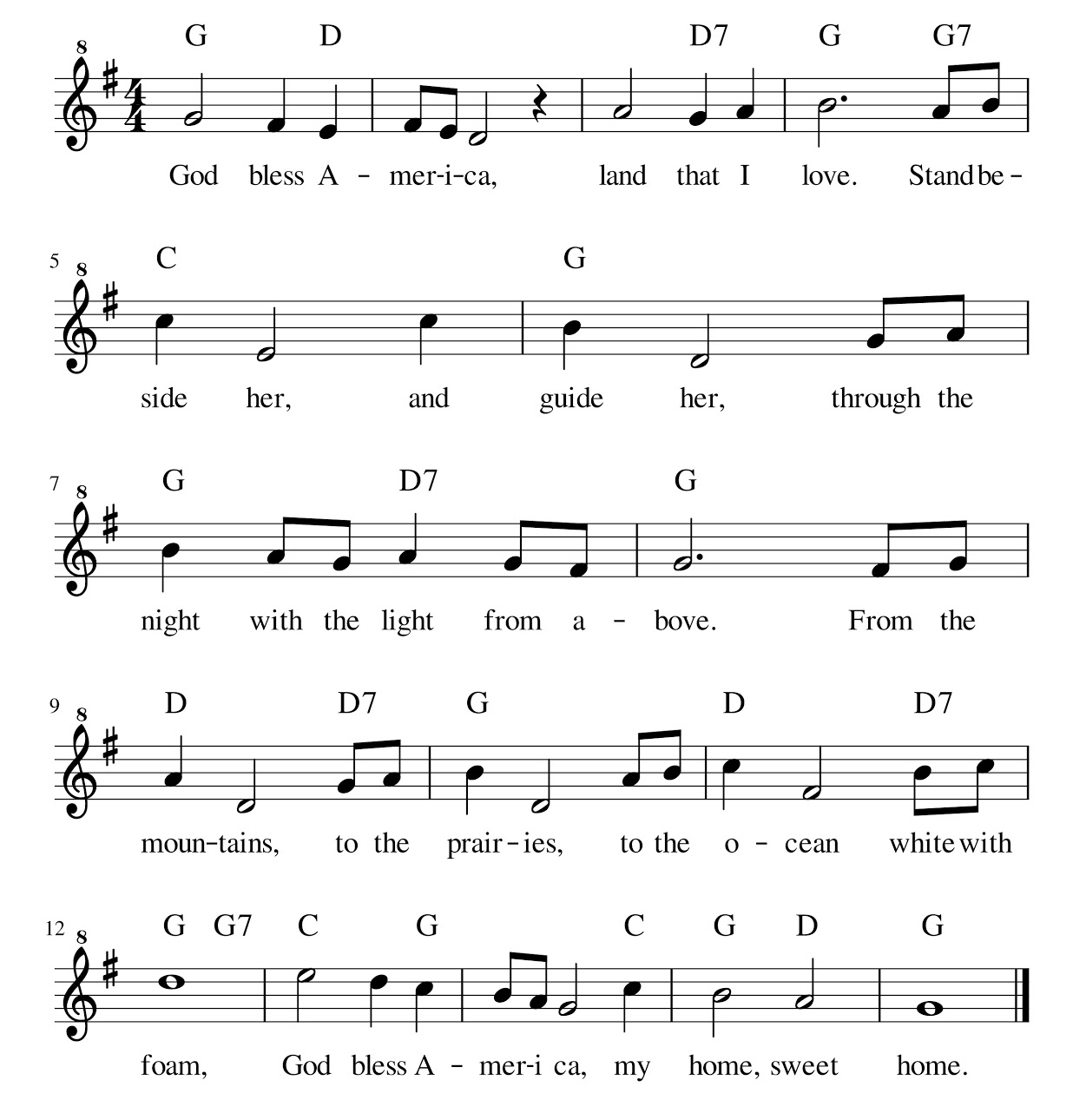
BENEDICTION
Pastor: The time has now come for us to return to the particular circumstances of our own lives. Let us go forth strong in our faith and our hope.
Liturgist: God is making all things new in Jesus Christ and through the Spirit who lives in us. Jesus sends us into the world to witness to his love and to play a role in the new creation.
Pastor: May God, who knows our joy, our anger and our pain, guide us always…
Liturgist: May we be courageous and faithful.
All: May we live a life worthy of the Christian faith.
Amen.

POSTLUDE Holy Spirit, Descend Upon Us (Little)

Prayers for Peace: Confession. https://ploughshares.ca/publications/worship-resources/prayers-for-peace/
Resources for The Week of Prayer for Christian Unity and throughout the year (2009), jointly prepared and published by The Pontifical Council for Promoting Christian Unity and The Commission on Faith and Order of the World Council of Churches. Posted on the World Council of Churches website. (Written for World Day of Prayer, January 18-25)

